**Backpropagation**

Backpropagation is a multi epoch training methodology where we leverage chain rule and memoization to update weights.

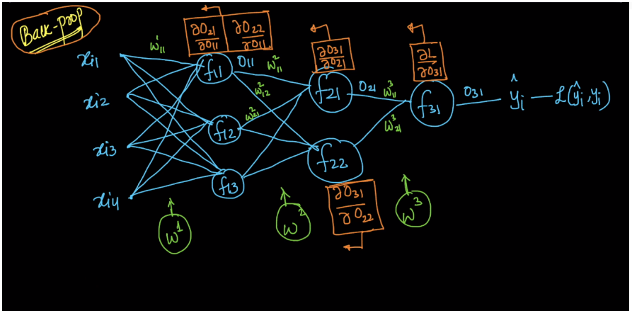

Algorithm of backpropagation is shown in below pic.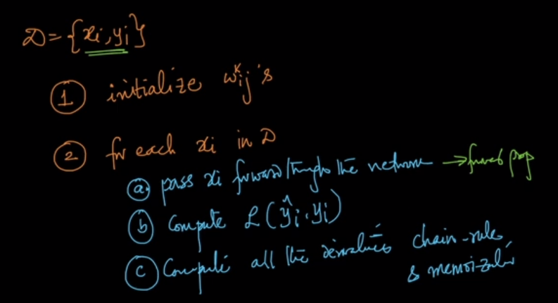

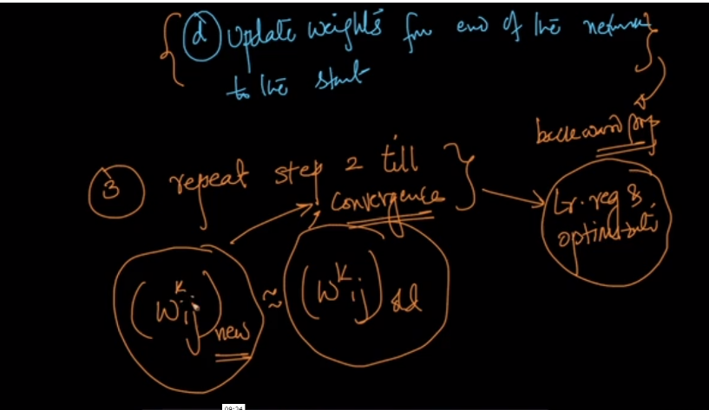

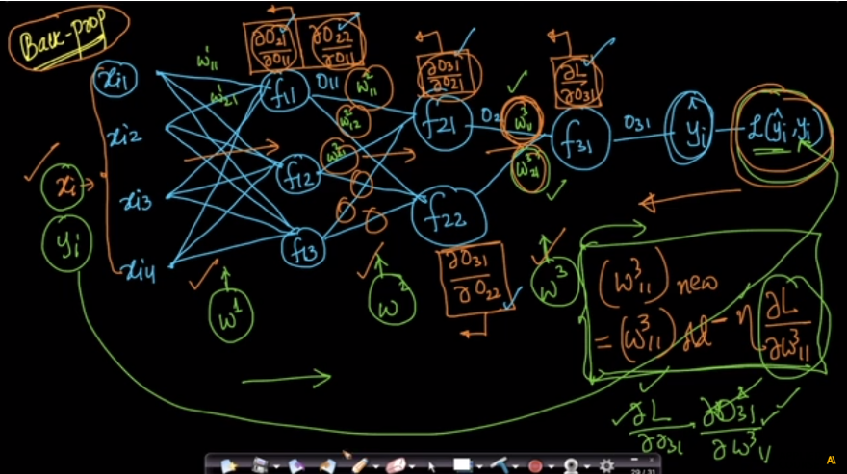

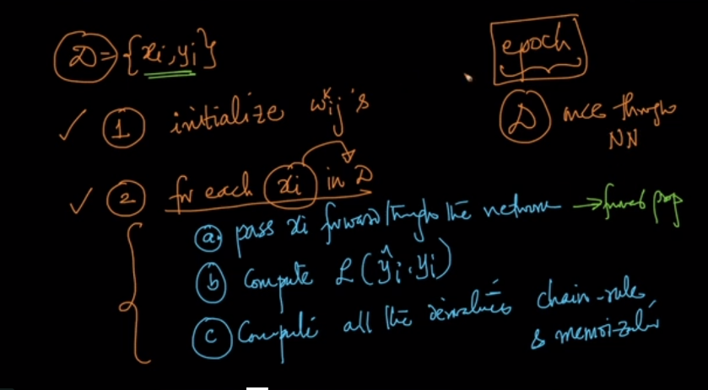

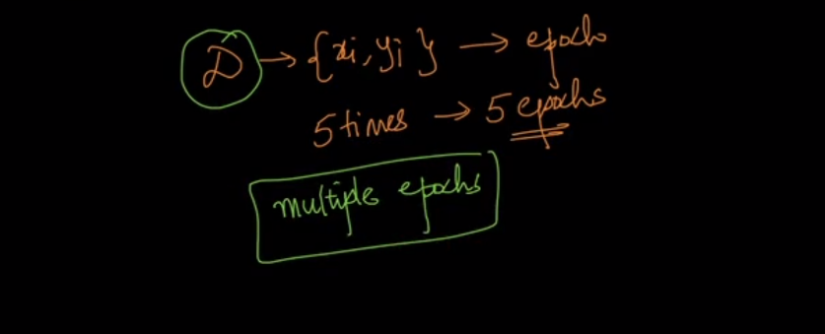

Main thing in backpropagation is computing derivative i.e chain rule +memorization because this is the only step which consumes more space and needs more time.

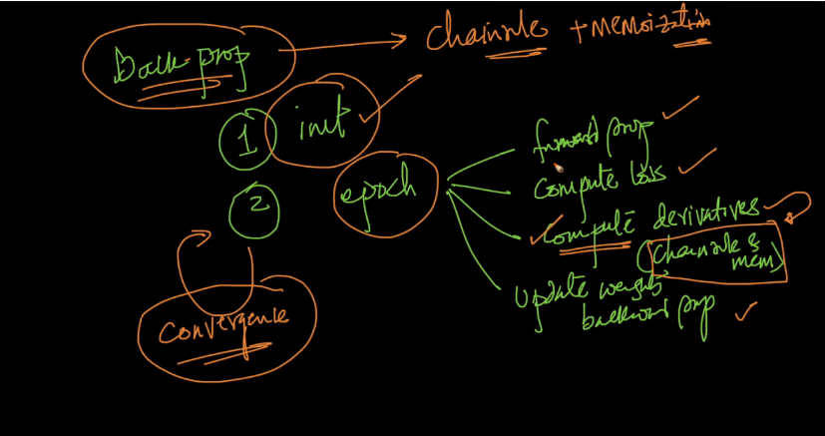

Backpropagation is only performed when activation functions are differentiable because we got output from this functions and if this functions are not differentiable then we can’t use chain rule.

Therefore if we our activation function is easily/fast differentiable then training time of nn will be speedup.

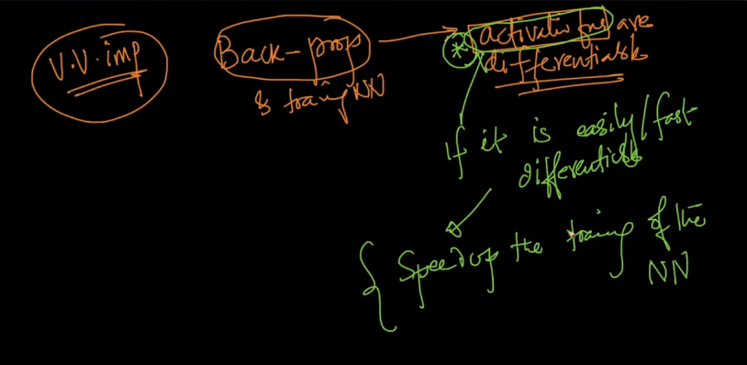

Right now what we are doing is giving single point at a time from data point in neural network i.e sgd.

Now there is also min-batch-sgd in which we give sets of data as an input.

Or in gd we give all points together as an input.

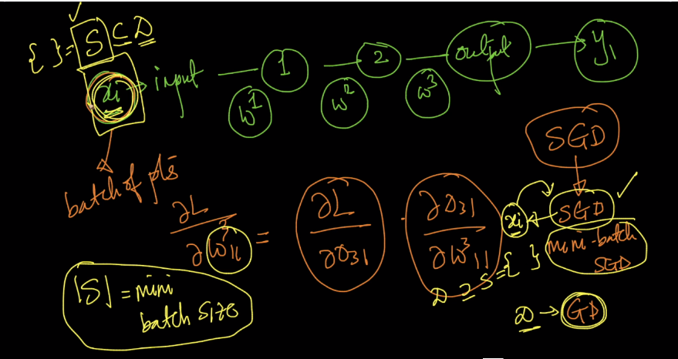

Mini-batch-sgd :

Suppose there are 10000 points and we select to give 100 points at a time ten 1 epoch is completed after running this loop 10000/100 = 100 times

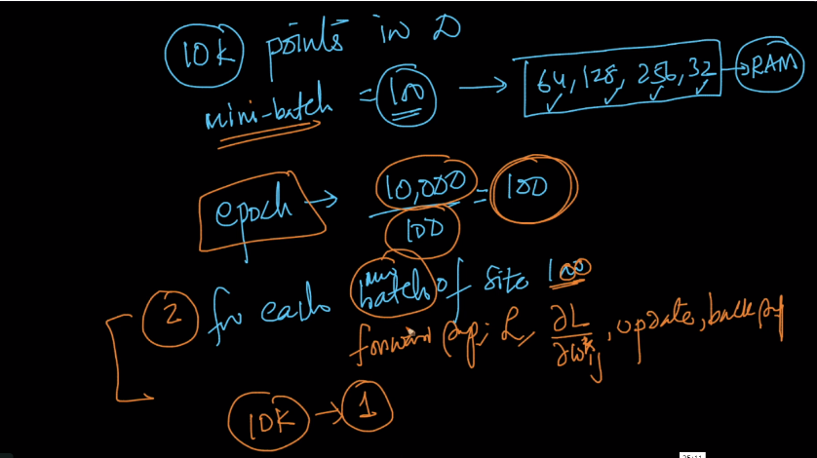

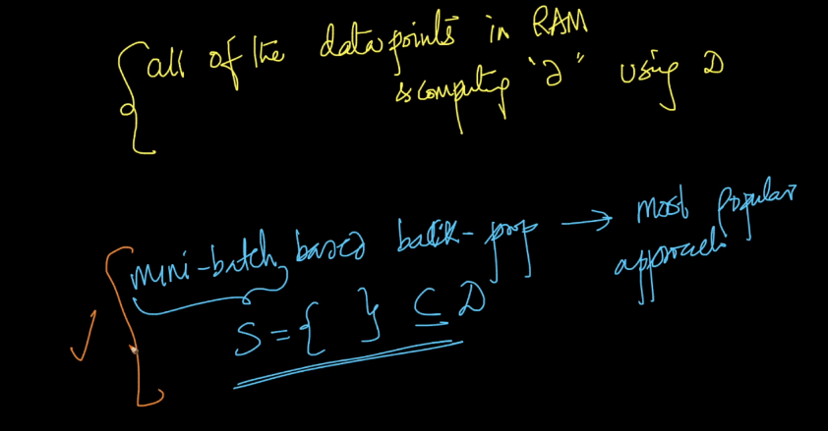

Links :

<https://medium.com/@14prakash/back-propagation-is-very-simple-who-made-it-complicated-97b794c97e5c>

<https://www.youtube.com/playlist?list=PLZHQObOWTQDNU6R1_67000Dx_ZCJB-3pi>

Comments:

